Earth Day 2020 – Carl Howard presentation
Essential reading: IPCC Reports
To find it on line (free):
Google: Summary - IPCC Fifth Assessment Synthesis Report
Here is the website: https://ar5-syr.ipcc.ch/topic_summary.php
There are numerous reports. Start with the Executive Summary, written for lay-persons.

Summary for Policymakers [SPM]SHARE

This Synthesis Report is based on the reports of the three Working Groups of the Intergovernmental Panel on Climate Change (IPCC), including relevant Special Reports. It provides an integrated view of climate change as the final part of the IPCC’s Fifth Assessment Report (AR5).

SPM.1. Observed Changes and their Causes

[presented qualitatively, stated with varying degrees of confidence, high/med/low, or as a straight-out fact. Unusual for a scientist.]
“Human influence on the climate system is clear, and recent anthropogenic emissions of greenhouse gases are the highest in history. Recent climate changes have had widespread impacts on human and natural systems. {1}”

Figure SPM.4

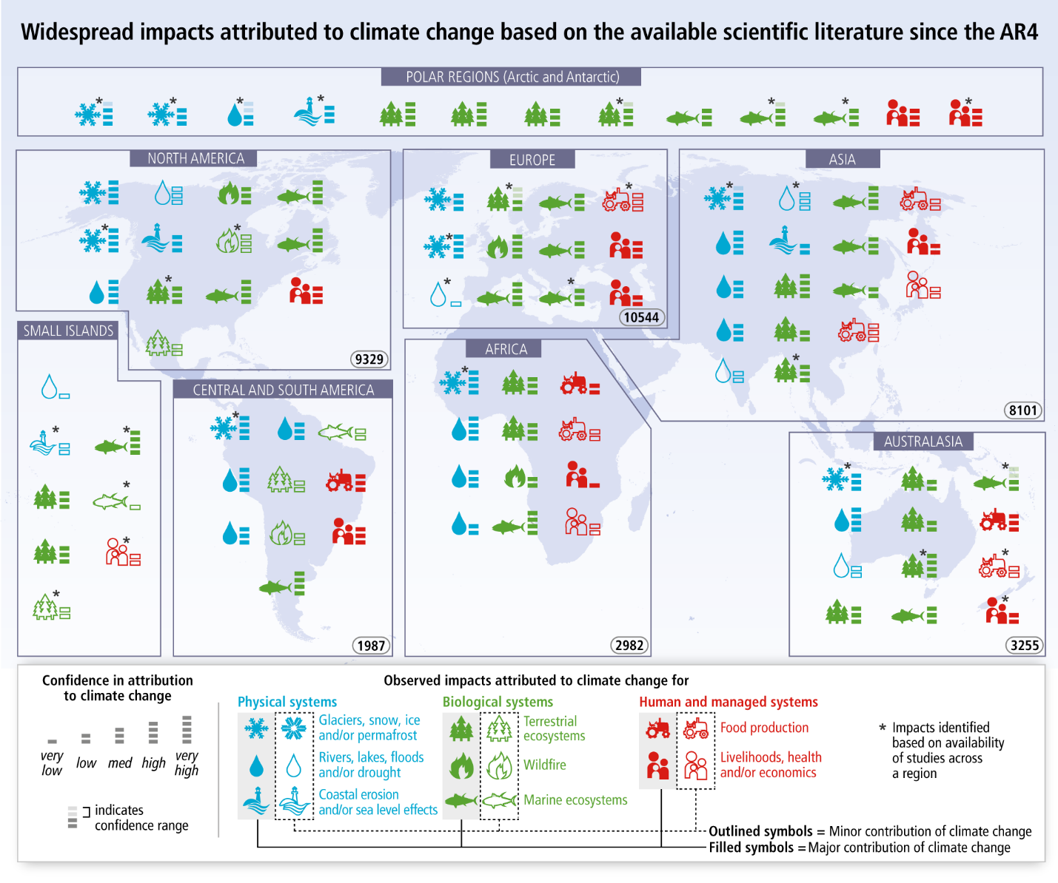

SPM.2. Future Climate Changes, Risks and Impacts

Figure SPM.8

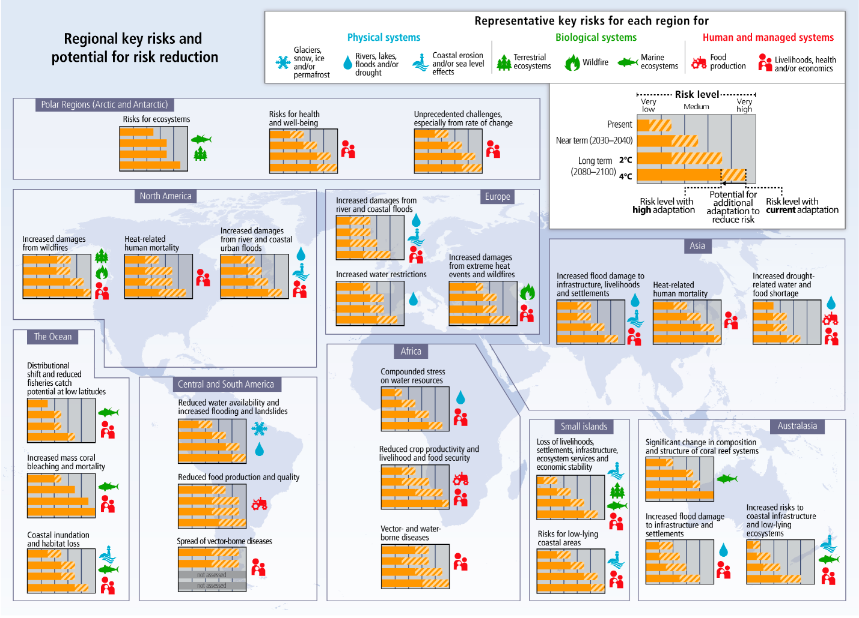

SPM.3. Future Pathways for Adaptation, Mitigation and Sustainable Development

Table SPM.1 | Key characteristics of the scenarios collected and assessed for WGIII AR5. For all parameters, the 10th to 90th percentile of the scenarios is shownª. {Table 3.1}
CO₂-eq Concentrations in 2100 (CO₂-eq) ^{f}  Category label | Subcategories | Relative position of the RCPs^{d} | Change in CO₂-eq emissions compared to 2010 (in %)^{c} |  | Likelihood of staying below a specific temperature level over the 21st century (relative to 1850-1900)^{d,e}
 |  |  | 2050 | 2100 | 1.5ºC | 2ºC | 3ºC | 4ºC
< 430 | Only a limited number of individual model studies have explored levels below 430 ppm CO₂-eq^{j}
450  (430 – 480) | Total range^{a,g} | RCP2.6 | -72 to -41 | -118 to -78 | More unlikely than likely | Likely | Likely | Likely
500  (480 – 530) | No overshoot of 530 ppm CO₂-eq |  | -57 to -42 | -107 to -73 | Unlikely | More likely than not
 | Overshoot of 530 ppm CO₂-eq |  | -55 to -25 | -114 to -90 |  | About as likely as not
550  (530 – 580) | No overshoot of 580 ppm CO₂-eq |  | -47 to -19 | -81 to -59 |  | More unlikely than likely^{i}
 | Overshoot of 580 ppm CO₂-eq |  | -16 to 7 | -183 to -86
(580 - 650) | Total range | RCP4.5 | -38 to 24 | -134 to -50
(650 - 720) | Total range |  | -11 to 17 | -54 to -21 |  | Unlikely | More likely than not
(720 - 1000)^{b} | Total range | RCP6.0 | 18 to 54 | -7 to 72 | Unlikely^{h} |  | More unlikely than likely
> 1000^{b} | Total range | RCP8.5 | 52 to 95 | 74 to 178 |  | Unlikely^{h} | Unlikely | More unlikely than likely

-----
My two-cents:
What these charts tell us is that even if every one of the 196 nations met its emissions reduction pledge under the Paris accord (not a single nation is on course to meet its pledged reduction), we still would likely exceed 2C temperature increase. We currently are about 1C above pre-industrial levels and we are seeing polar ice caps melt, global warming, sea level rise, alterations of air and oceanic currents which affects global weather systems and animal migration patterns, reduction of crop productivity and the beginning of environmental refugees fleeing failed states. At 2C we would enter the realm of “catastrophe” which we can predict because it has begun. It will just get worse. Much worse.
The good news is, as Al Gore, never tires of telling us, is that we understand the problem, we know what the solutions are (mostly ceasing GHG emissions and moving entirely to non-carbon emitting renewable energy sources) and we have all the technology to move aggressively in the right direction. What we lack is the political will and leadership to move in a new direction. But that can be achieved.

